March 2020
016
20162016
ember 2011



Tynan Studio

Questions and/or concerns regarding privacy and security may be directed to:

Senior Database Administrator
& Privacy Officer
privacy@pogo.ca

480 University Avenue
Toronto ON M5G 1V2
Phone: 416-592-1232
Toll Free: 1-855-FOR-POGO
Fax: 416-592-1285
www.pogo.ca

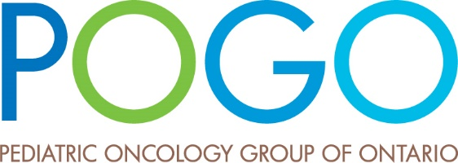
Healthcare innovation
Survivor care
Family assistance
Population data
Policy development
Research
Education

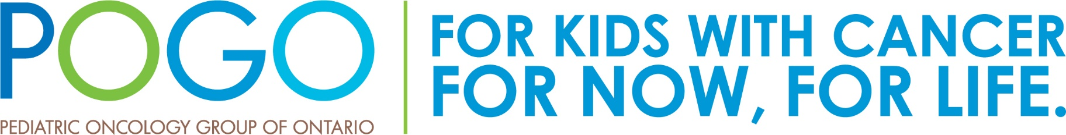

Privacy

Program

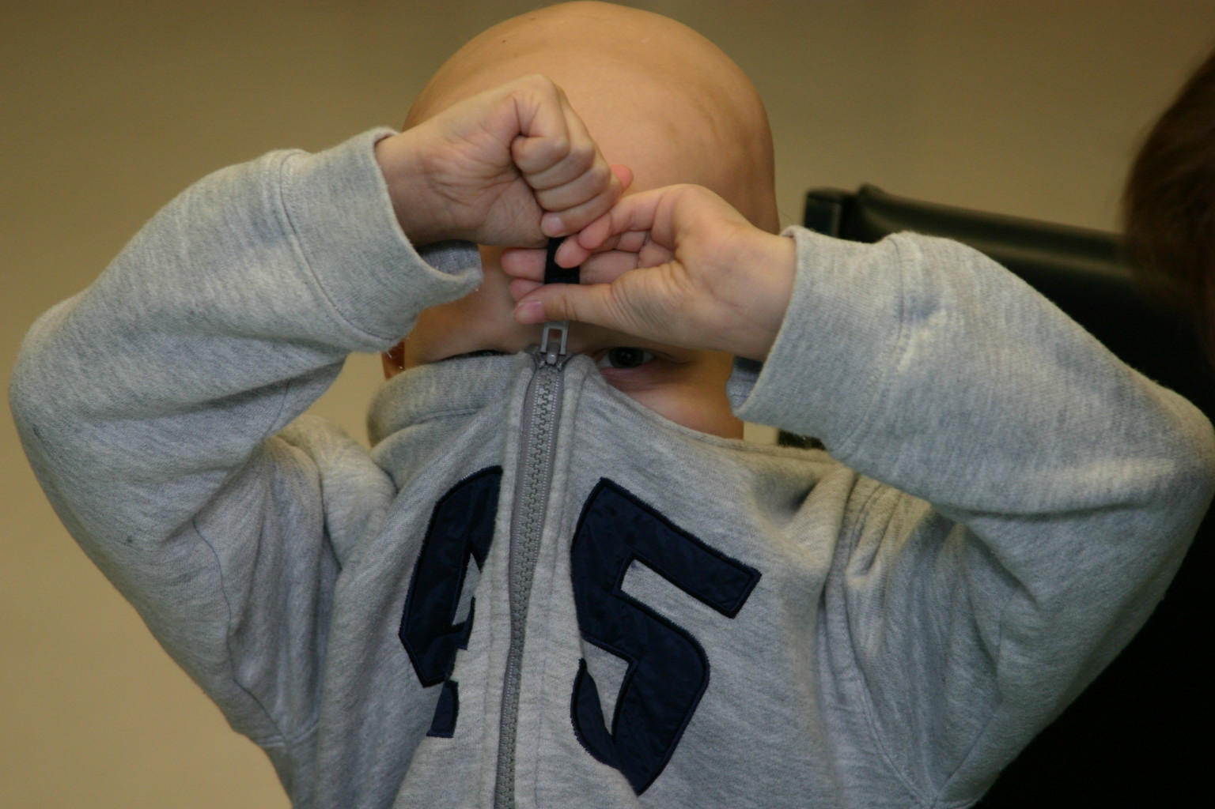

Zipping Up for Security

We are committed to ensuring

the privacy and security of

personal health information

Our Database: POGONIS

The childhood cancer data within the POGO Networked Information System (POGONIS) supports POGO and its partners in planning for childhood cancer control in Ontario, and is a valuable resource for analysis and the research activities it supports.

The POGONIS database contains the following health information for each child diagnosed with cancer in Ontario since 1985:
- Demographic information (e.g., full name, address, postal code, date of birth, sex, health card number);
- Diagnosis information (e.g., cancer type, date of diagnosis, histology information);
- Treatment information (e.g., type of treatment, dose, date, place); and
- Death information (e.g., date of death, cause, location).

POGO collects information from the five tertiary pediatric hospitals in Ontario, the eight formal POGO Satellite sites, the seven pediatric and adult AfterCare programs affiliated with the tertiary pediatric hospitals, and a Prescribed Registry (CCO). Designated staff at these centres transmit information by private, secured electronic data lines.

POGONIS is designed to monitor:
- The incidence and prevalence of childhood cancer;
- The demand for care and workload of pediatric oncology programs;
- The nature and specifics of treatment; and
- Patient outcomes and long-term effects of childhood cancer and its treatment.

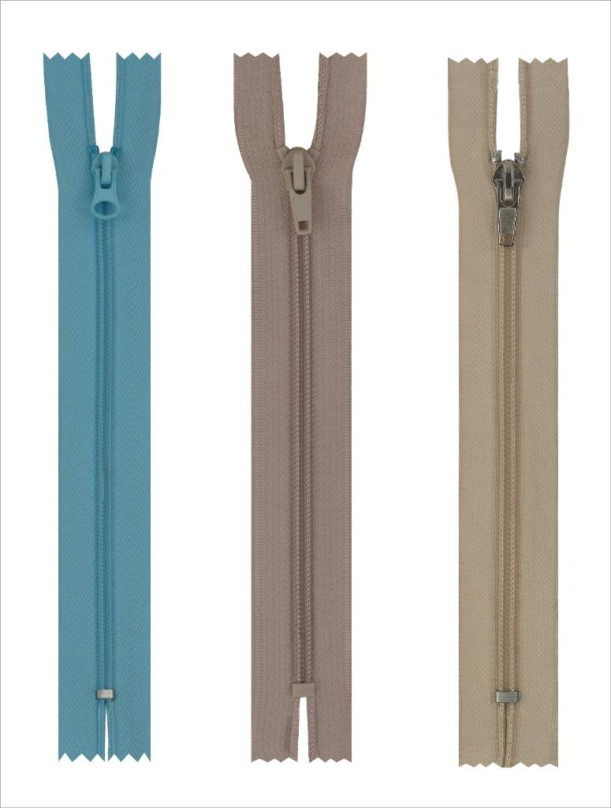
POGO’s Privacy Code

POGO's Privacy Code is based on the ten principles of the Canadian Standards Association Model Privacy Code for the protection of personal health information found in Canada’s federal privacy legislations. Among these principles is our commitment to:
- Limiting use, disclosure, and retention: POGO limits the collection of personal health information to that which is necessary for the identified purposes. The amount and the type of personal health information collected is limited to that which is necessary to fulfill its purposes as a prescribed 45 entity.
- Safeguards: POGO protects all personal health information within its custody and considers it to be highly sensitive. The safeguards POGO has put in place include physical, organizational, and technological measures. Examples include: a locked facility with tracked card access; internal and external video monitoring of POGO; confidentiality agreements signed by all employees, researchers, and affiliated individuals; the use of firewalls, passwords, encryption, and anonymization of data; and a virtual private network.
- Accountability: POGO is responsible for all data held in its possession or custody and designates individuals who are accountable for compliance with specific principles.
- Openness: Information about our privacy policies and practices is available in both printed format and on our website (www.pogo.ca).
- Challenging compliance: Individuals have a right to know which data sources POGO uses for analysis and research and, for additional information, can be referred to the organization that collects their data.

What is POGO?

The Pediatric Oncology Group of Ontario (POGO) is a not-for-profit, multi-disciplinary, multi-centre collaboration of health professionals representing the pediatric programs that treat children with cancer across the province of Ontario.

Established in 1983, POGO aims to improve the circumstances of Ontario’s children with cancer, their families, and caregivers through the development and implementation of an accessible, well-integrated provincial childhood cancer system. In 1995, POGO was designated as official advisor to the Ministry of Health (MOH) on childhood cancer control.

POGO plans for provincial pediatric oncology needs, coordinates the allocation of funding across the province, maintains the provincial pediatric oncology database (the POGO Networked Information System, POGONIS), provides clinical leadership, and develops evidence-based standards and guidelines for childhood cancer care.

POGO undertakes analyses and conducts research focusing on childhood cancer in the following areas:
- Epidemiology
- Health services research
- Health economics
- Status of survivors/quality of life

POGO’s recommendations are based on solid provincial data, scientific evidence, and clinical experience.

Strong partnerships and an unfaltering collaboration between the specialty childhood cancer programs and professionals have led to notable successes over the years.

POGO’s Privacy Program: Our Commitment to Privacy

POGO was designated as a 45 entity under Ontario’s Personal Health Information Protection Act (PHIPA) in November 2004. This designation allows POGO to collect, use, and disclose personal health information without consent for the purposes of analyzing and compiling statistical information that assists with the management, evaluation, monitoring, distribution of resources, and planning for the health care system which includes the delivery of services (PHIPA, 2004).

POGO uses personal health information to:

Analyze the demographics and epidemiology of cancer in children;
- Identify trends and outcomes related to childhood cancer treatment;
- Identify gaps in the delivery of cancer care services;
- Develop, implement, and evaluate new treatment programs; and
- Determine the optimal location of such programs.

POGO is responsible for securing all data including personal health information, confidential, and sensitive data in its custody and control.

Section 44 of PHIPA permits POGO to conduct research focusing on childhood cancer. Researchers are required to follow a comprehensive set of policies, guidelines, and procedures that protect and secure the privacy and confidentiality of individuals with respect to their personal health information, and that they protect this information against theft, loss, unauthorized use, disclosure, copying, modification, and disposal.

